**Project Documentation**

Senior Citizens

Timer:

The timer is made to show and record the speed in which the user completes the given puzzle. This is done in the javascript backend via a series of built in functions. The source code that was used as a basis for this project contained a number of javascript files, one of which was one called userActions.js. This file holds the functions that dictate what happens when the users interact with the game. Using javascript we are able to set global variables to then be used throughout the functions.

For the timer, the following code snippet shows the variables declared. The timer variable uses document.getElementById to return an element object that represents an element of the HTML whose Id matches the input. This is shown in the following HTML code snippet that shows how there is an element that is created with the id “stopwatch”.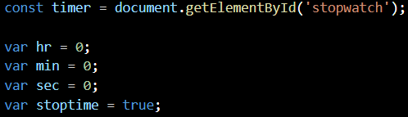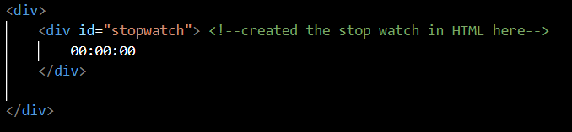

This is created as constant as there is no change in what element is being referred to. The variables for the time functions are all declared as var as they are constantly being changed in the functions. The main function that controls the timer is the timerCycle() function. This checks to see if the timer is running based on the stoptime variable. The sec, min, and hr variables are all currently storing the numbers as strings so using the parseInt they are converted to integers. The sec variable is increased by 1 and if sec has hit 60 then min is increased by 1 and the same for min and hr. The following if statements are used to create the 0 before the number in cases of 0-9 for the times. This would allow for the representation of 00:01:05 instead of 0:1:5 which would be harder to read. This function is finished off with using innerHTML to put the string of hr, min, and sec together to output to the HTML to be printed. 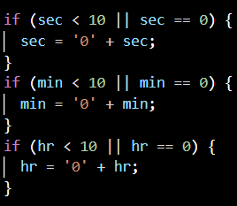

The final line of the function setTimeout(“timerCycle()”,1000) is a javascript function that acts as an internal timer to call the specified function every 1000 milliseconds so that 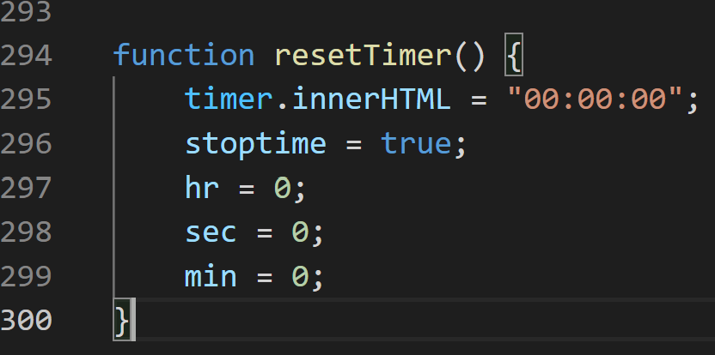

the time will change every second.

The last function in userActions.js is the resetTimer() that uses inner HTML to put the string output to the HTML printed back to zero and resets the values of sec, min, and hr when resetting the timer.

Submit Button

When the submit button is pushed, the submitHandler() function in userActions.js is run, which creates a valid board in and compares the inputs by running runTests() in validate.js. This function evaluates if the board is fully completed with the correct inputs.

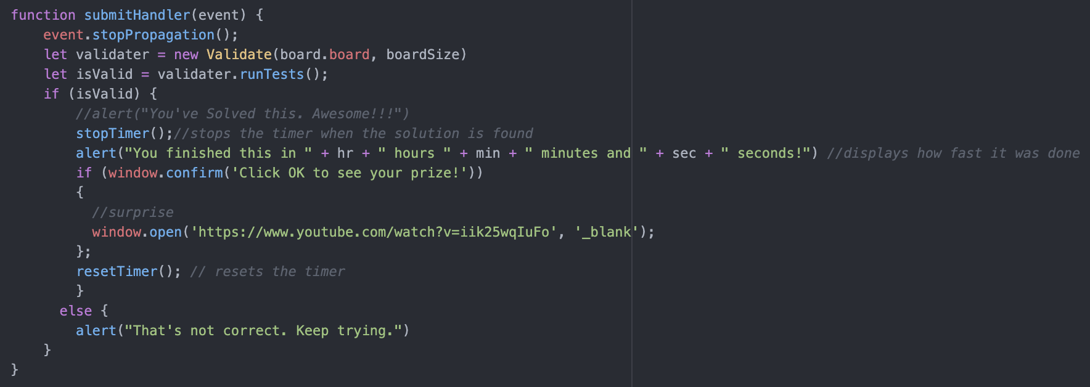

If the user has not completed the board, or if one or more inputs are incorrect, an alert message saying "That's not correct. Keep trying." pops up.

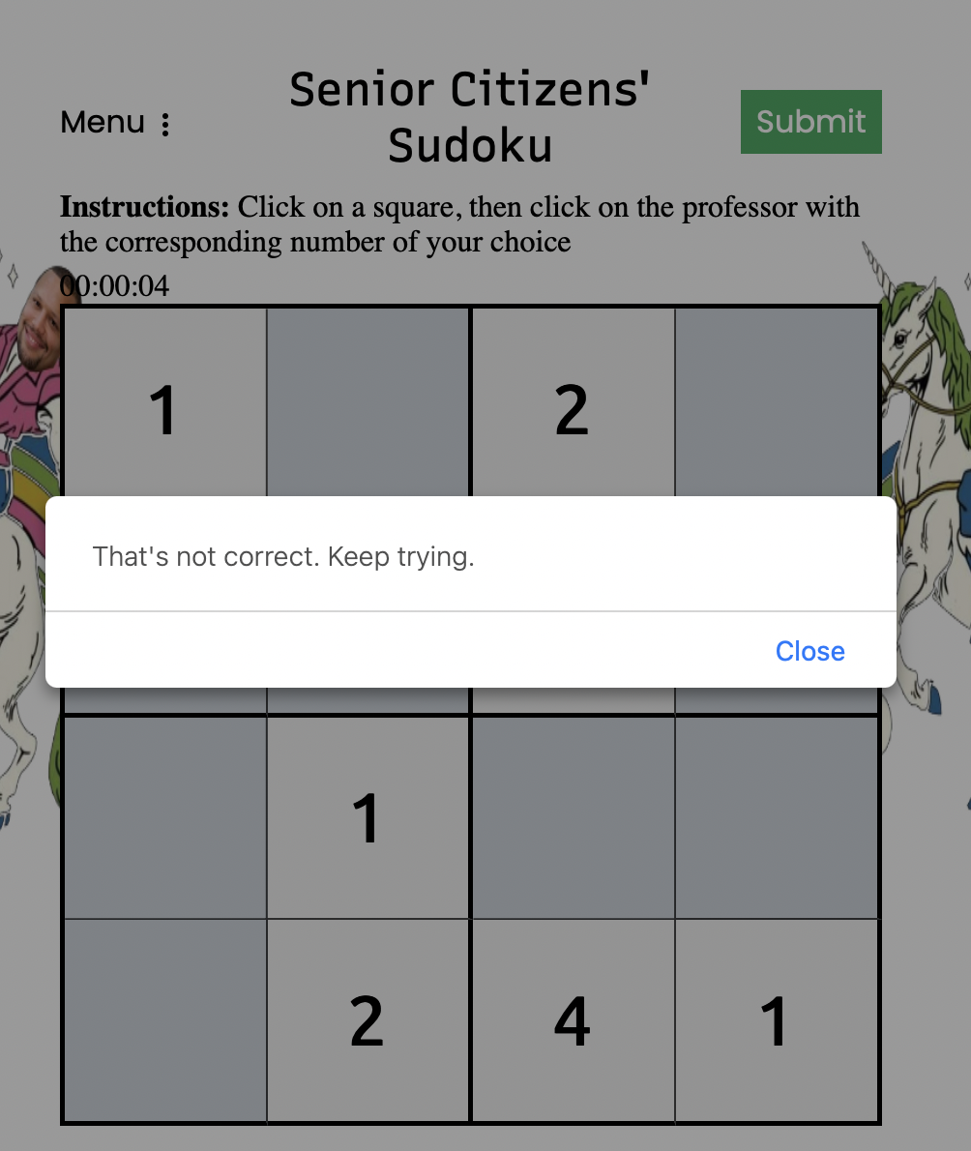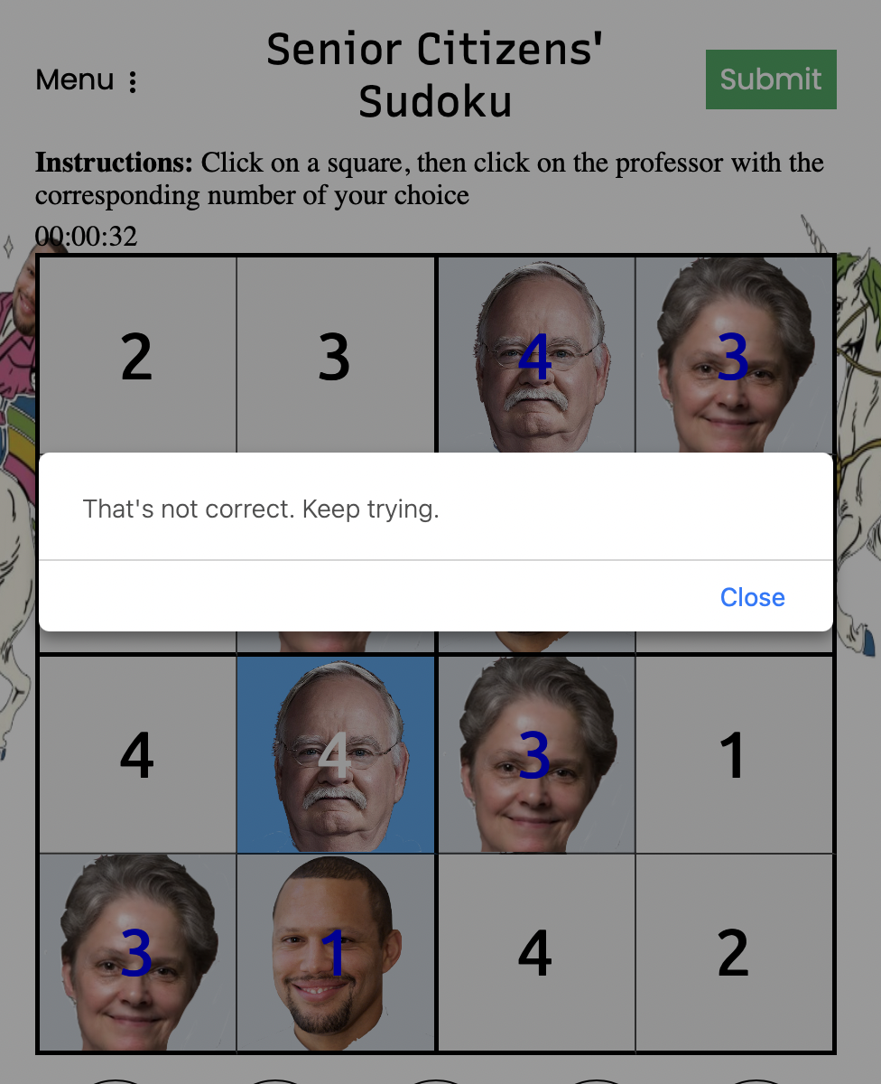

If the user has completed the board and all inputs are correct, an alert message pops up and states that the user has finished the board with the time once started to when the submit button was pushed. Once closed, a confirmation message pops up saying “Click OK to see your prize!” If the user chooses to press OK, they will be sent to a linked url.

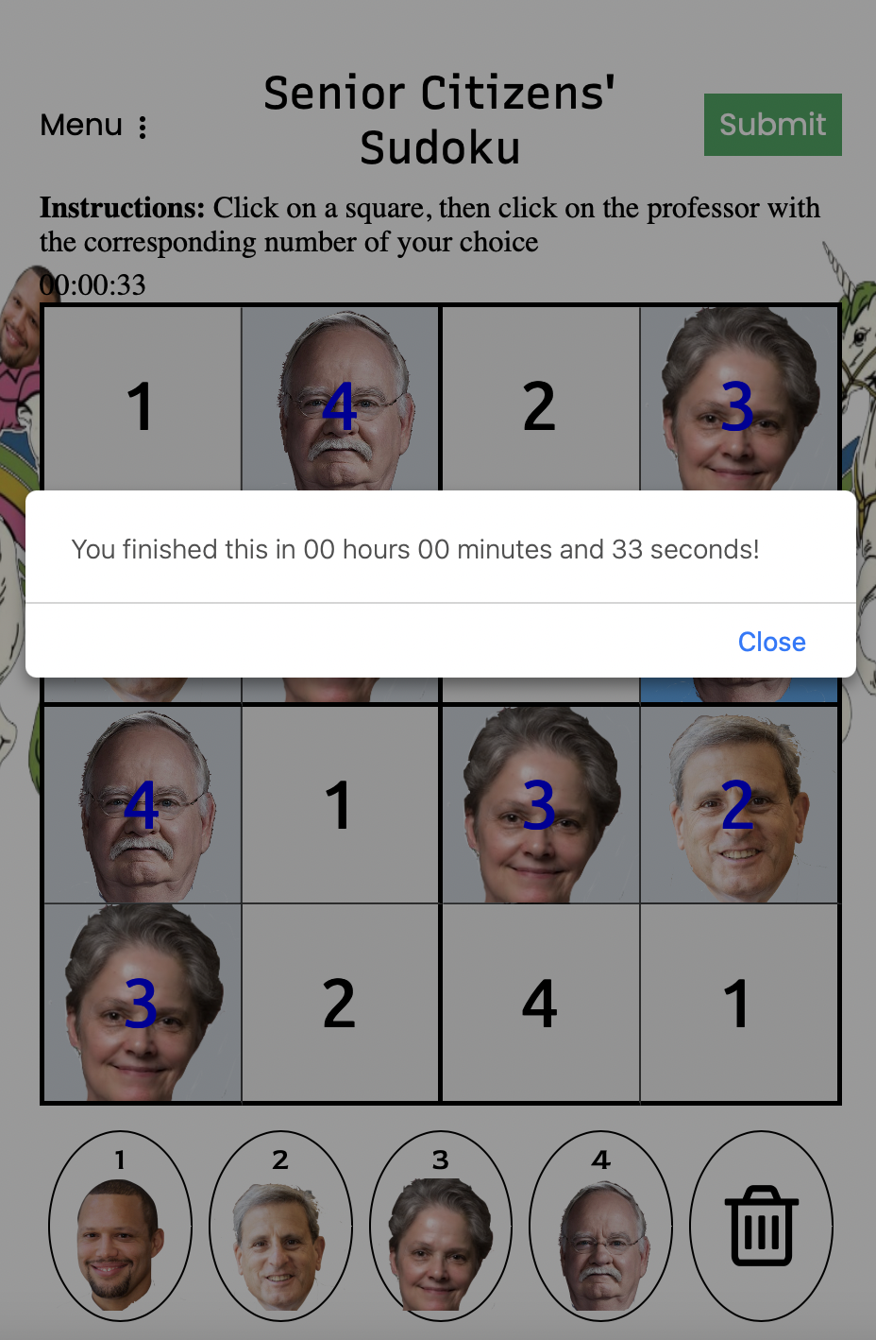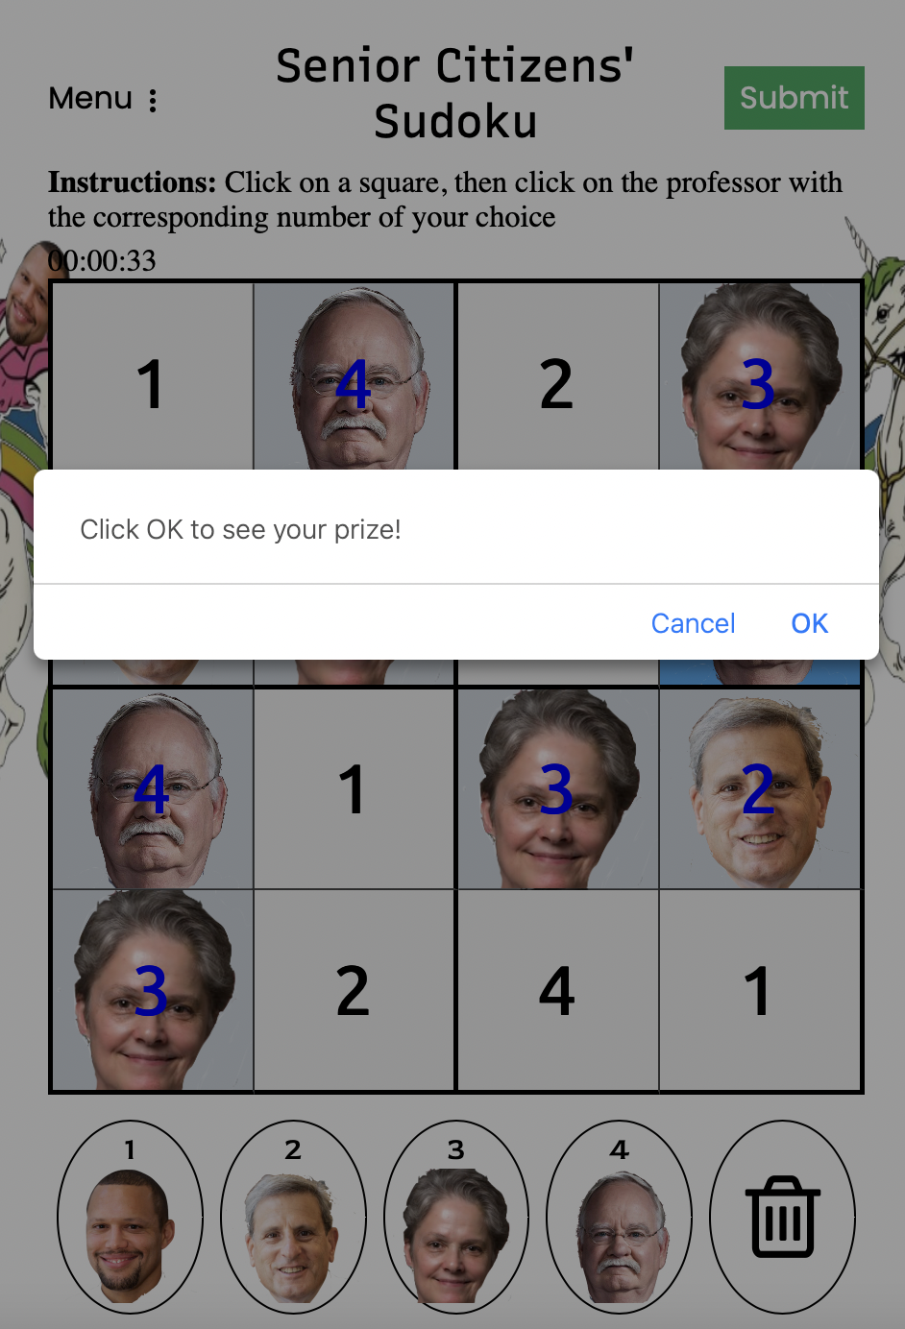

Images in the Keypad/Selection Elements:

The images in the keypad are declared in class View, in the createBoardHTML(size) function definition.

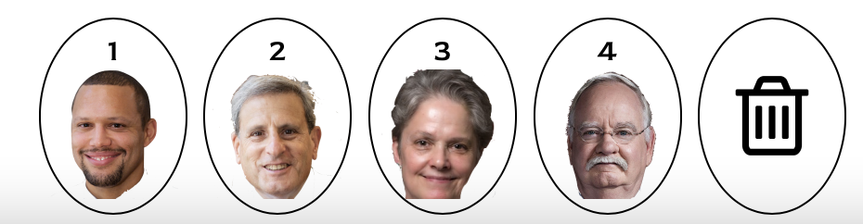

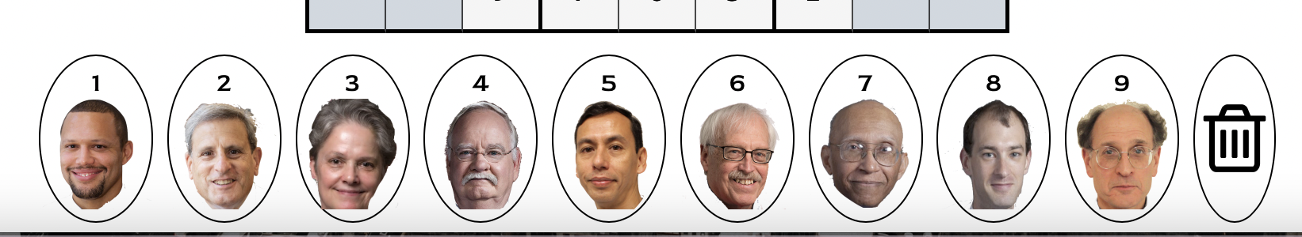

The Document method querySelector() returns the first Element within the document that matches the specified selector, #keypad. The following line resets the variable html that was declared and used earlier in the function.

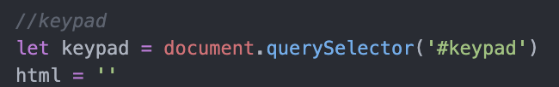

The following for loop and switch statement runs through the elements of the keypad, starting at the zero index and ending with one less than the previously declared size when size is selected by the user. The user selects either the 4x4 grid or 9x9 grid, where size is 4 or 9, respectively. The following code creates a keypad of selected size, plus one for the trash can. The <span> tag marks up the keypad item with the number of the item and the image of the corresponding professor. After the switch statement, the <span> tag is used to add the image of the trash can as the last markup. These markups are stored in the variable “html.”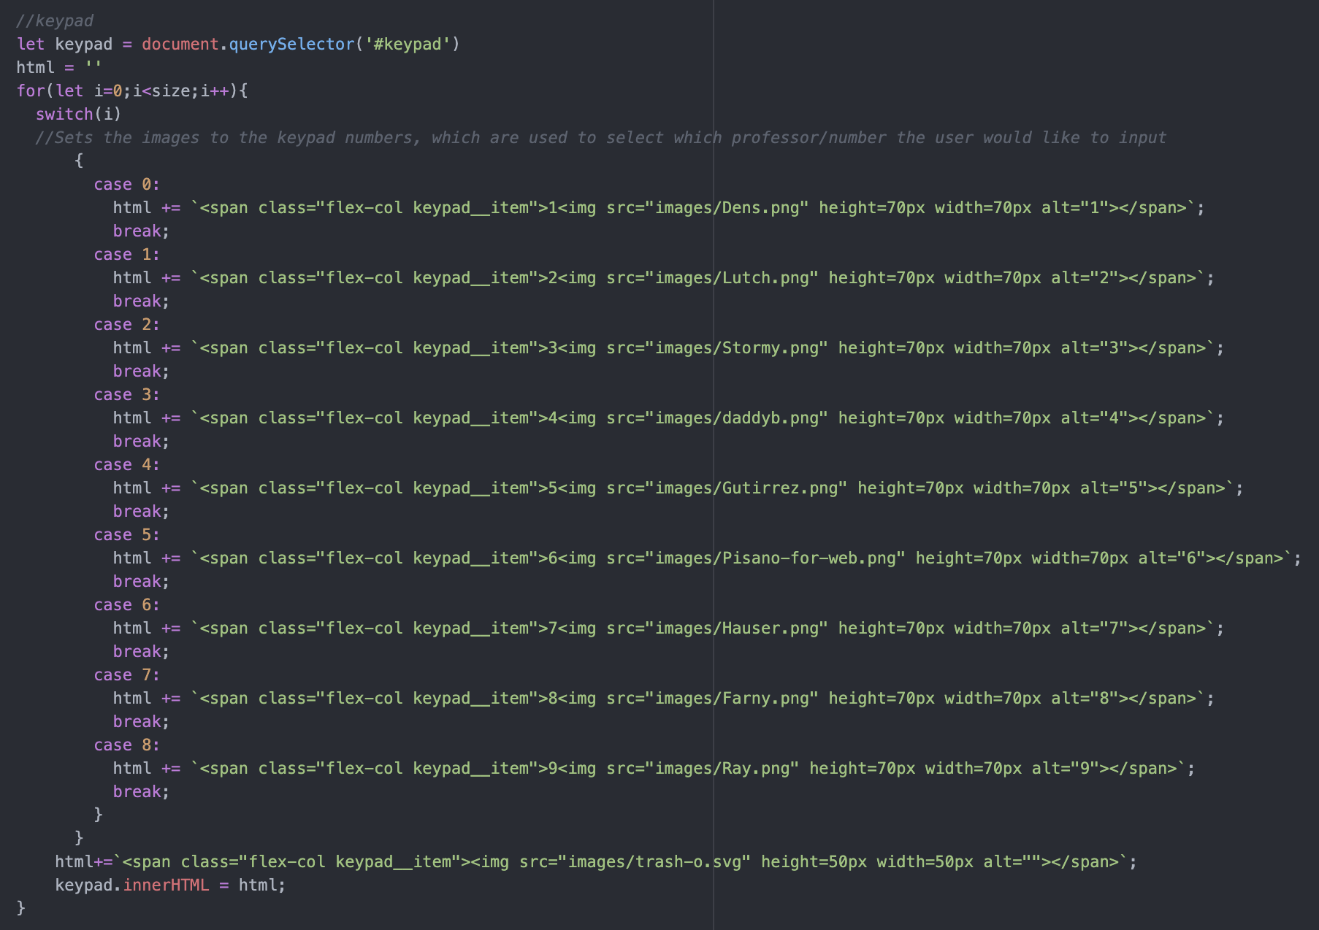

The Element property innerHTML sets the HTML markups contained within the keypad.



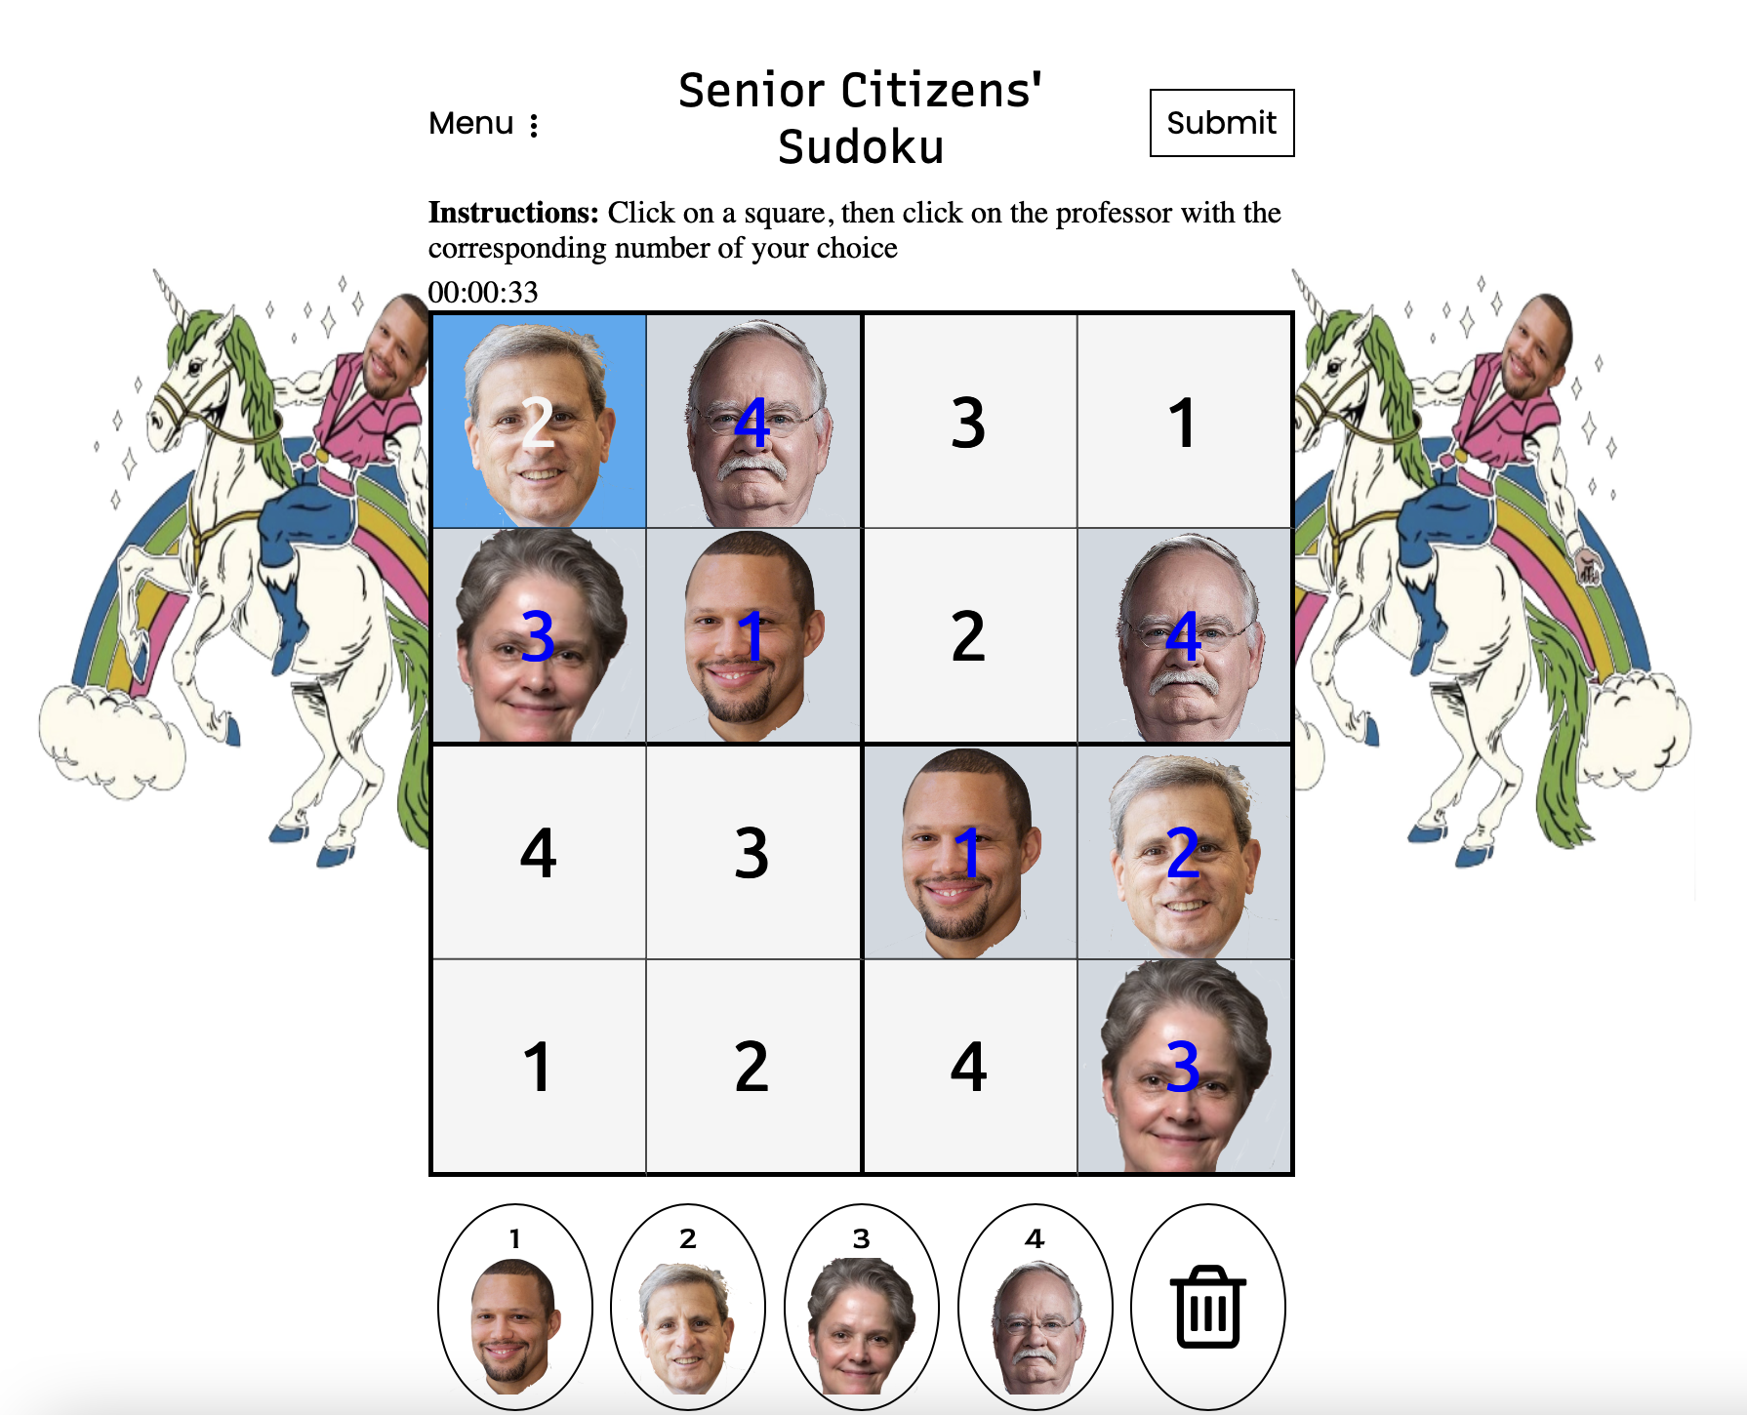

User Input Image Elements:

The user input when playing the game works by clicking on the square on the board and clicking on a number/professor in the keypad of choice. This function is made in the function keyPadHandler(event) in the userActions.js file. When keyPadHandler(event) is called, it uses the selected input and reads the text input that is inputted by clicking the keypad. This text input is a string, this.textContent.

parseInt(this.textContent) converts its first argument to a string, parses that string, then returns an integer or NaN which is the number that is inputted into the board square. The if statements then evaluate the number and the if statement sets the background of that square to the professor corresponding with the number value using .style.backgroundImage.

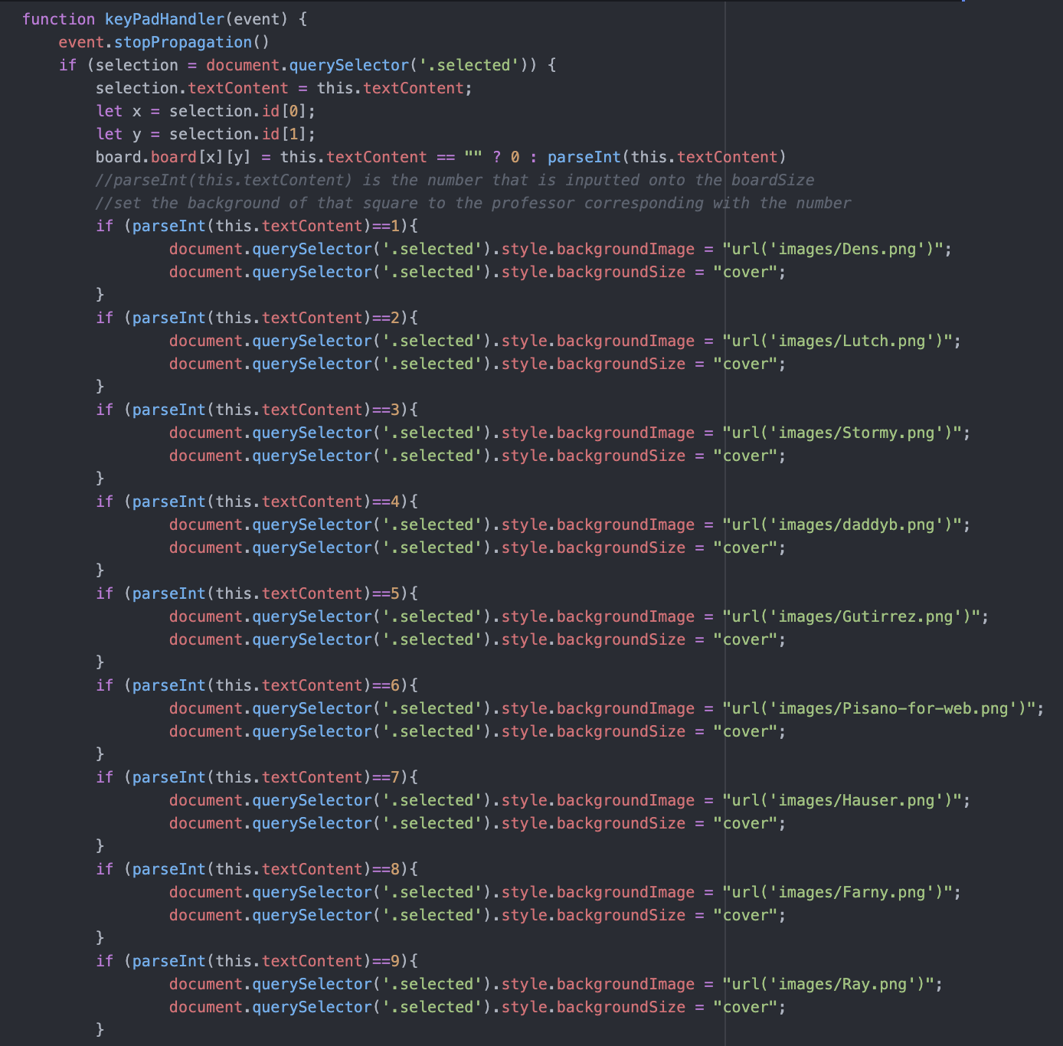

This last if statement evaluates if the input is empty, setting the background image to none/taking the professor’s face image away.

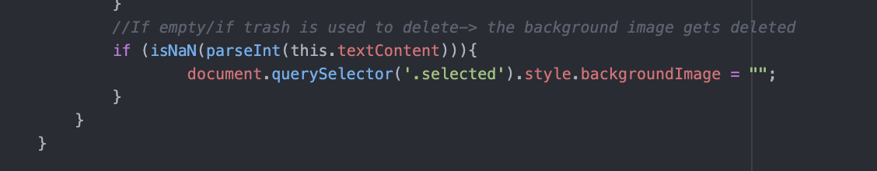

Drop-down Dot Menu: Clear All Button

When the user clicks “Clear All” on the drop-down menu, an alert confirmation message pops up, to confirm that the user would like to clear all inputs. If the user clicks OK, all inputs are cleared and the timer does not stop.

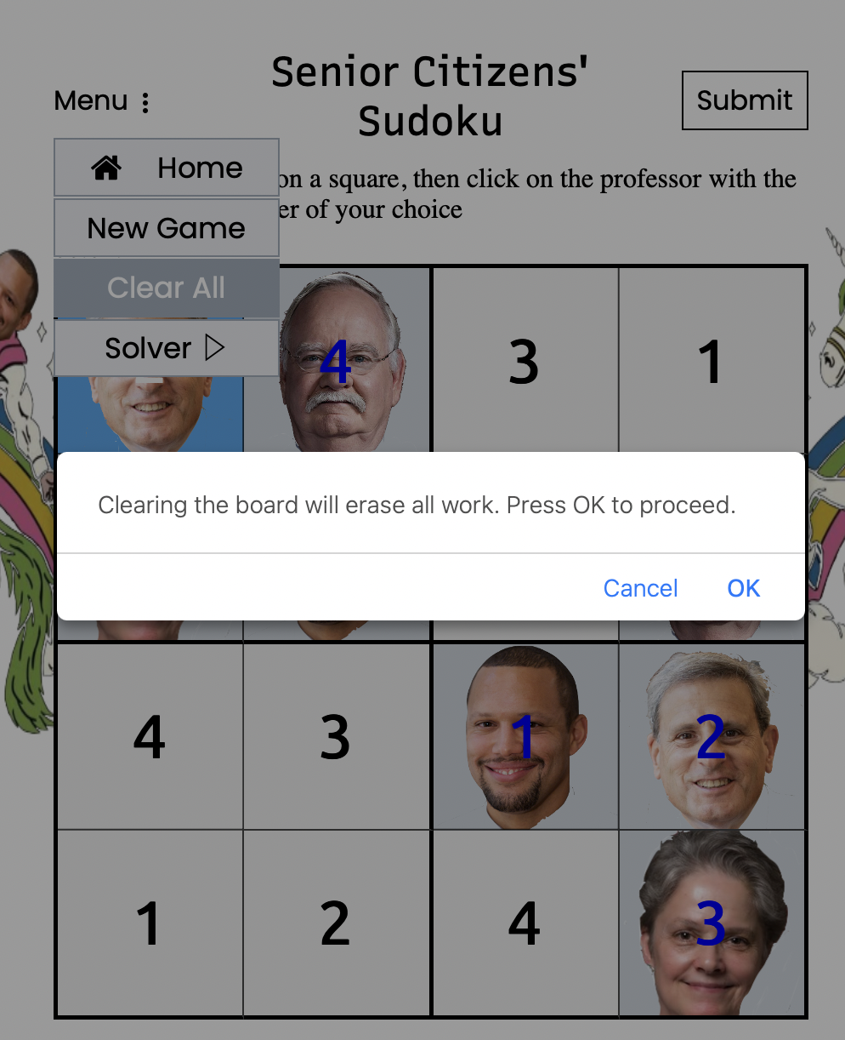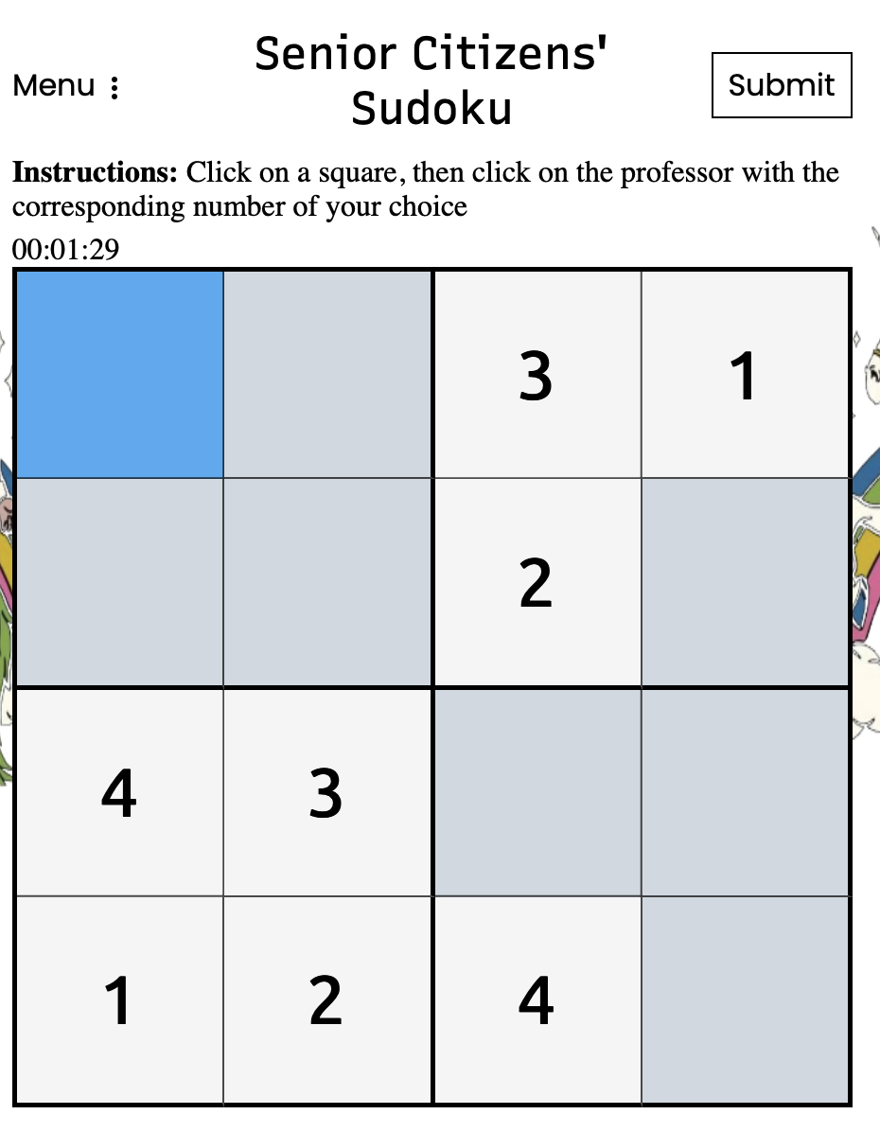

This is a part of the function, dotMenuHandler(e), in userActions.js. The if statement evaluates the user’s answer to the confirmation message. If they click OK, clearUserInput() is called, which calls copyBoard() and view.printBoard() which copy and reprint the same board without the inputs. 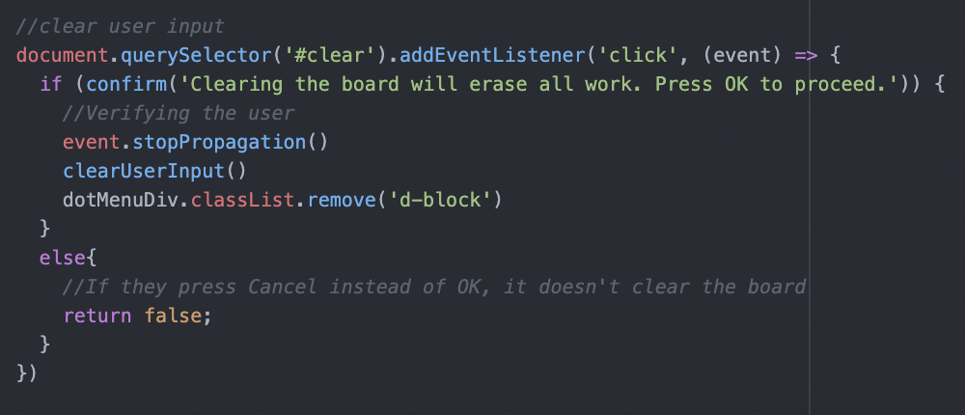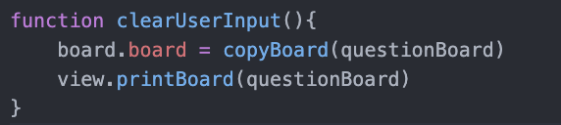

In printBoard(), the function runs through a nested for loop going through each row and column for the particular size of the board, “textContent”s are cleared and the backgroundImage is reset to none.

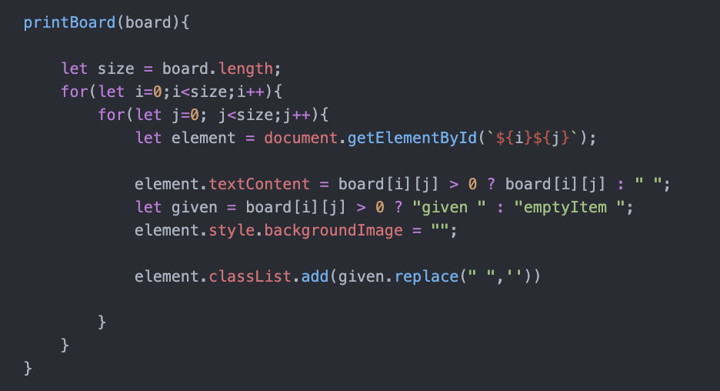

Drop-down Dot Menu: New Game Button

When the user clicks “New Game” on the drop-down menu, an alert confirmation message pops up, to confirm that the user would like to start a new game. If the user clicks OK, a new board is created, the backgrounds reset, and the timer resets.

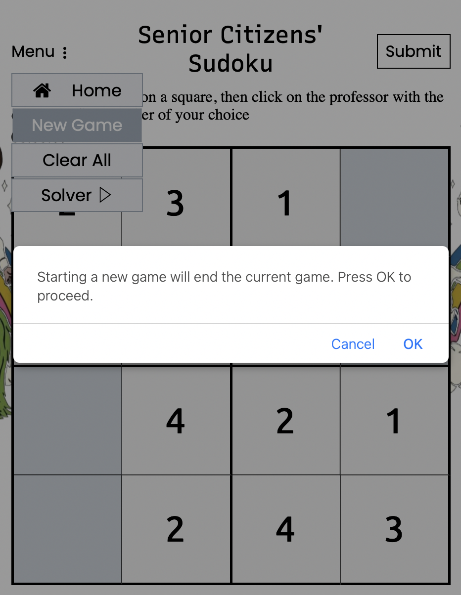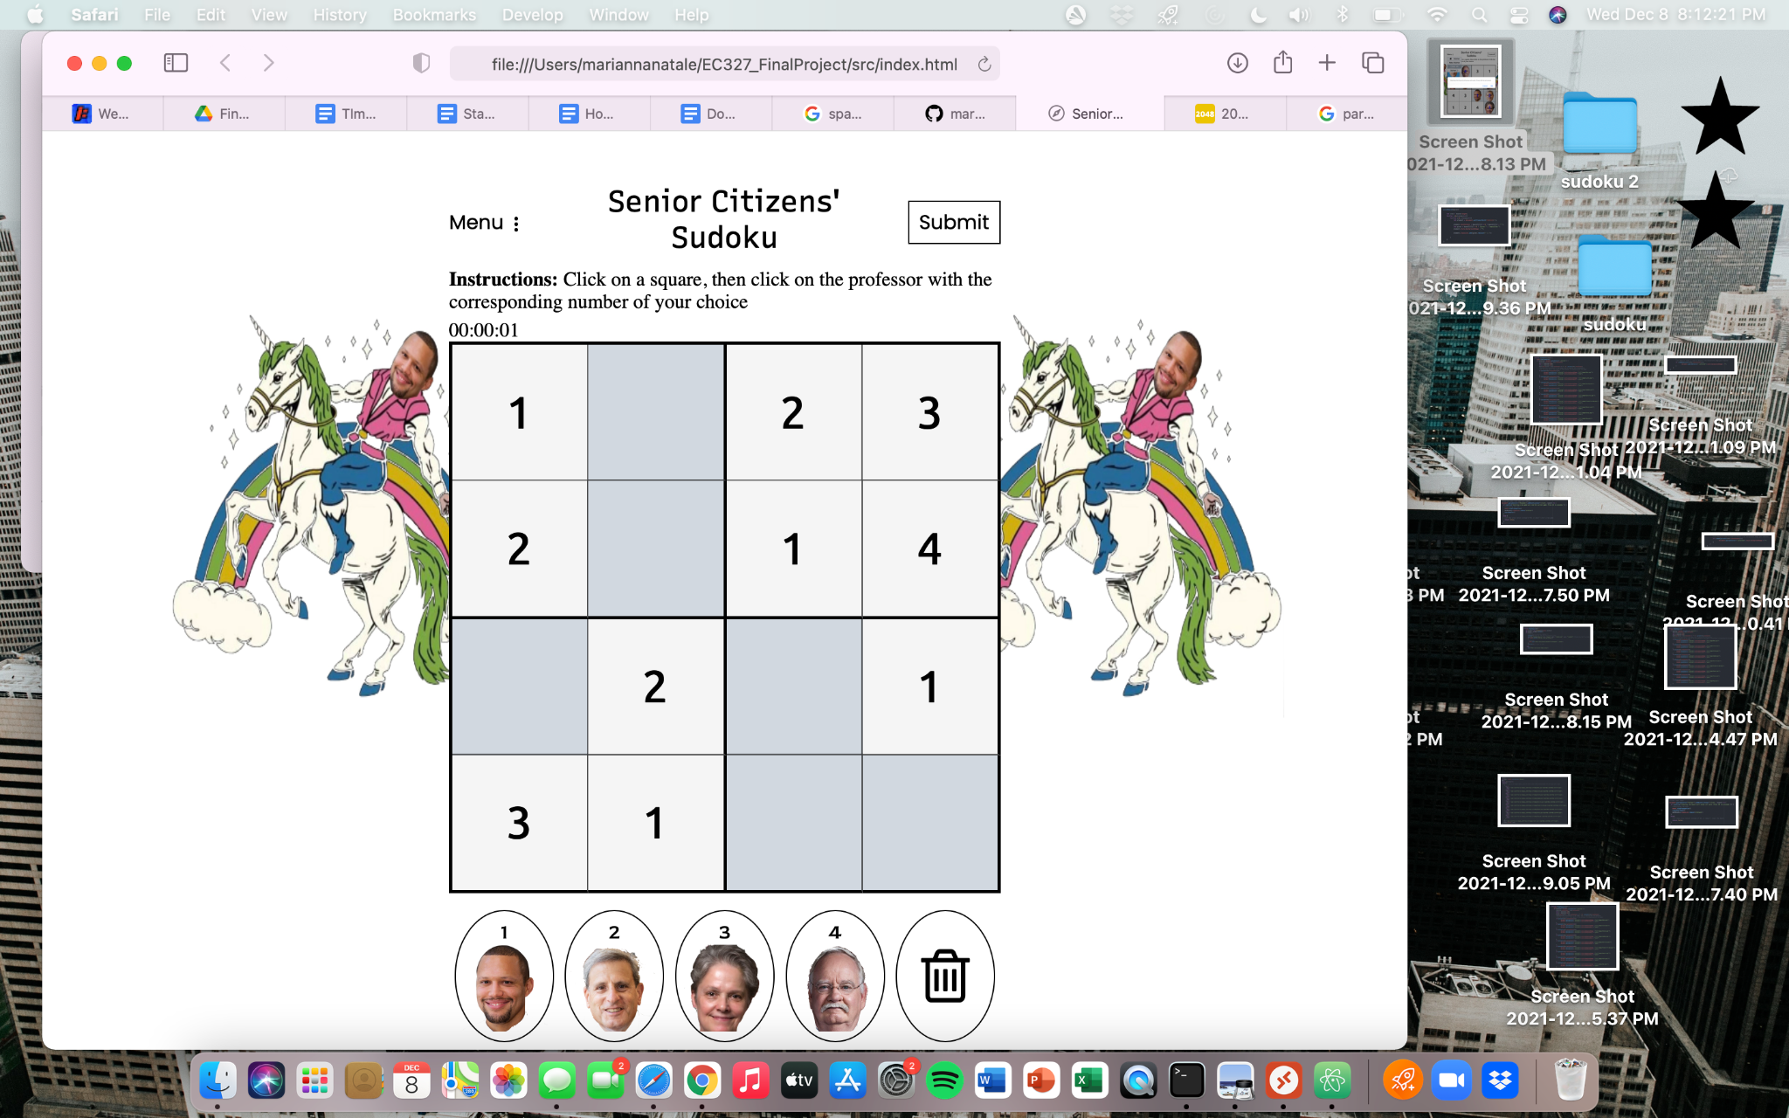

This is a part of the function, dotMenuHandler(e), in userActions.js. The if statement evaluates the user’s answer to the confirmation message. If they click OK, the hr, min, sec (time) is set to 00:00:00 and startHandler() is called to start a new game, which is the same function that starts a new game when the Begin button is pressed on the home screen.

